MovieUniverse

Software Requirements Specification

Version 1.0

08.03.2023

Roaya Heib
QA Tester

Prepared for
Samana Project
Winter 202

Revision History
Date | Description | Author | Comments
08.03.2023 | Version 1.0 | Roaya Heib | This is the first version

Document Approval
The following Software Requirements Specification has been accepted and approved by the following:
Signature | Printed Name | Title | Date

Table of Contents

Revision History ii
Document Approval ii
1. Introduction 1
1.1 Purpose 1
1.2 Scope 1
1.3 Glossary 2
2. General Description 2
2.1 Product Functions and User Characteristics 3
2.2 General Constraints 4
2.3 Assumptions and Dependencies 5
3. Specific Requirements 5
3.1 Hardware requirements 5
3.2 Software requirements 5
3.3 Functional Requirements 6
3.4 Non-Functional Requirements 7
3.4.1 Performance 7
3.4.2 Reliability 7
3.4.3 Security 7

1. Introduction
The Movie Management System is an application that enables users to manage a database of movies and reviews. The system is built using:
- Flask web framework,
- SQL Alchemy database toolkit.
- Flask-Migrate extension for database migrations.

Purpose

The main purpose of this document is to provide the Software Requirements Specification (SRS) for the MovieUniverse project.

1.2 Scope
An application based on Python Flask for managing movies.
The application has the following features:
- Add a movie.
- View all movies.
- View specific movie data including reviews and ratings.
- Delete a movie including all its data, reviews, and ratings.
- Alter movie data.
The application uses SQL Alchemy for database management and Flask-Migrate for database migrations. It also allows users to upload an image file for each movie.
The code is structured into different Flask routes, each handling a specific functionality.
The database models are defined using SQL Alchemy in a separate file, which is imported into the main Flask application file.

1.3 Glossary
Terms | Definition
User | The person who uses the website.
Database | Collection of all information monitored by this system.
Movie | a story or event recorded by a camera as a set of moving images and shown in a theater or on television; a motion picture.
Watchlist | a convenient place to save movies from your collection in a list to remind you to watch later.
Data | facts and statistics collected for reference or analysis.

2. General Description
This is a web application that manages a movie database. It uses Flask as the web framework and SQL Alchemy as the ORM, to communicate with the SQLite database.
The application has several routes that handle different tasks:
- home route displays a list of all movies in the database.
- add_data route displays a form that allows the user to add a new movie to the database.
- movie_info route displays details about a specific movie, including reviews and ratings.
- add_review route allows users to add reviews for a specific movie.
- erase route deletes a movie from the database.
- Finally, alter_movie route allows the user to edit the details of a specific movie.
Detailed explanation for each route:
- The add route handles adding a new movie to the database. It first checks if the file uploaded by the user is an allowed file type (png, jpeg, jpg, or gif). If it is, it generates a random string and adds it to the filename to ensure that each file has a unique name. It then saves the file to the server and adds a new row to the movies table with the movie details and the filename of the poster.
- The add_review route handles adding a new review to the database. It creates a new row in the reviews table with the reviewer's name, the review text, the rating, and the ID of the movie being reviewed.

- The erase route deletes a movie from the database. It first retrieves the filename of the movie poster from the movies table, deletes the file from the server, and then deletes the row from the movies table. It also deletes all reviews associated with the movie from the reviews table.
- The alter_movie route allows the user to edit the details of a movie. It retrieves the details of the movie from the movies table, updates them with the new values submitted by the user, and then commits the changes to the database.

2.1 Product Functions and User Characteristics

The application is a movie management system that allows users to view and manage movies and their related information, such as reviews, actors, and release year.

The application has several routes, including:
- ['/'], which renders the home page and displays all movies in the database.
- '/add_data', renders the add profile page to add new movies to the database.
- '/add', adds new movies to the database when submitted.
- '/display/<filename>', displays images uploaded to the application.
- '/movie_info/<movie_id>', displays detailed information about a specific movie, referring to its ID, including its reviews.
- '/add_review', adds new reviews for a specific movie when submitted.
- '/delete/int: id', deletes a movie from the database when submitted, referring to its ID.
- '/alter_movie/int: id', allows users to edit information about a specific movie when submitted, referring to its ID.
The main features of the application include:
- Displaying a list of all movies in the database on the home page.
- Adding new movies with information such as title, description, director, release year, image file, main actors, budget, genre, duration, proper age, and video link.
- Displaying detailed information about a specific movie, including its reviews and overall rating.
- Allowing users to add reviews for a specific movie, including their name, review text, and rating.
- Allowing users to edit or delete existing movies, as well as all reviews associated with that movie.
The application uses the Flask web framework, the SQL Alchemy database toolkit, and the Flask-Migrate library for managing database migrations. It also uses random string modules for generating random strings to append to image filenames for uniqueness. The application supports image files with extensions [.png, .jpeg, .jpg, and .gif], and has a maximum file size of 16 MB.
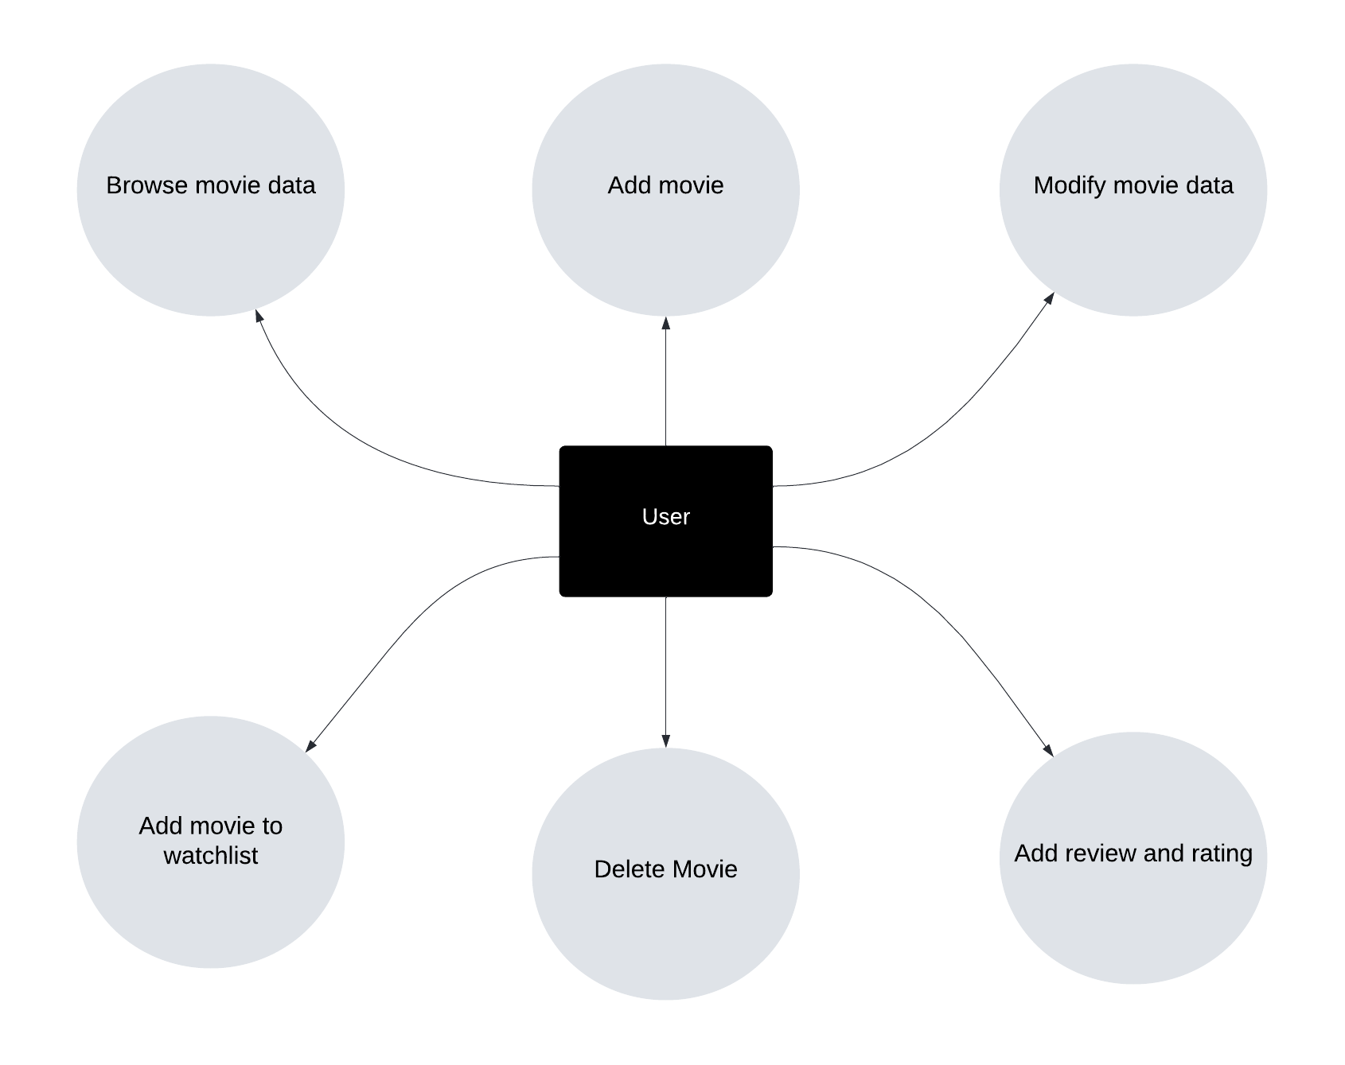

2.2 General Constraints

To run the system, several criteria must be fulfilled:
- Core i5 or later.
- Flask web framework,
- SQL Alchemy database toolkit.
- Flask-Migrate extension for database migrations.

2.3 Assumptions and Dependencies
2.3.1 Assumptions
The system assumes that users have a basic understanding of web browsers and the internet.
The system assumes that users will only upload valid image file types (png, jpeg, jpg, gif).
The system assumes that the database will be hosted on a server and accessible to the application.
2.3.2 dependencies
Flask web framework
SQL Alchemy database toolkit
Flask-Migrate extension for database migrations.
Python programming language.

3. Specific Requirements
3.1 Hardware requirements
A computer or server capable of running Python 3.6 or later.
Sufficient storage to host the database and image files.

3.2 Software requirements
Python 3.6 or later
Flask web framework
SQL Alchemy database toolkit
Flask-Migrate extension for database migrations.
SQLite database
An operating system capable of running Python and the required software.

3.3 Functional Requirements
The system does not require user registration, and there is no login functionality. Any user can access the system and perform the following functions:

3.3.1 Add Movie
The system allows a user to add a new movie to the database. The user enters the following information about the movie: title, description, director, release year, main actors, budget, genre, duration, and proper age. The user can also upload an image file for the movie, which is saved in the 'static/uploads/' directory. The image file must be a valid file type (png, jpeg, jpg, gif) and must not exceed 16 MB.

3.3.2 Delete Movie
The system allows a user to delete a movie from the database. When a movie is deleted, its corresponding image file is also deleted from the 'static/uploads/' directory. All reviews associated with the movie are also deleted.

3.3.3 View Movie Information
The system allows a user to view information about a particular movie, including its title, description, director, release year, image, main actors, budget, genre, duration, and proper age. The user can also view reviews and ratings for the movie.

3.3.4 Add Review
The system allows a user to add a review for a particular movie. The user enters their name, review text, and a rating between 1 and 5. The review is associated with the corresponding movie.

3.4 Non-Functional Requirements

3.4.1 Performance
The system must be able to handle many movies and reviews. The database must be able to store and retrieve data quickly.

3.4.2 Reliability
The system must always be reliable and available. The system must be able to recover from errors and handle exceptions gracefully.

3.4.3 Security
The system must be secure and protect user data. The system does not require user registration, so there are no user passwords to protect. The system should prevent unauthorized access to the database and server.

